**DBMS LAB**

**ASSIGNMENT-4**

**SNEHA SINGH**

**20198023**

**IT 5 B2**

**Q 1. Considering the given relations, operate the following queries:**

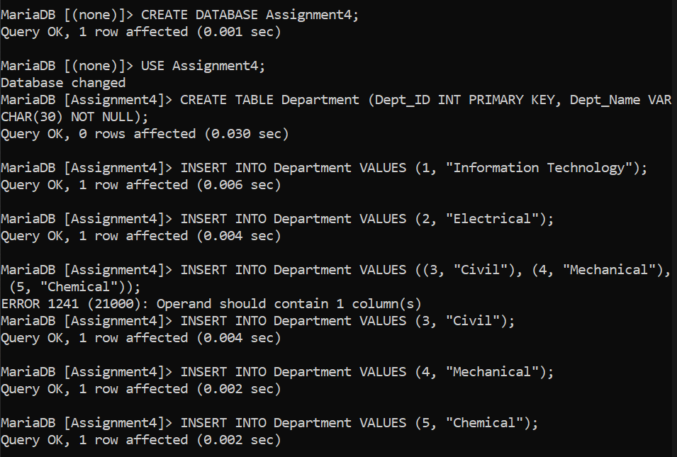

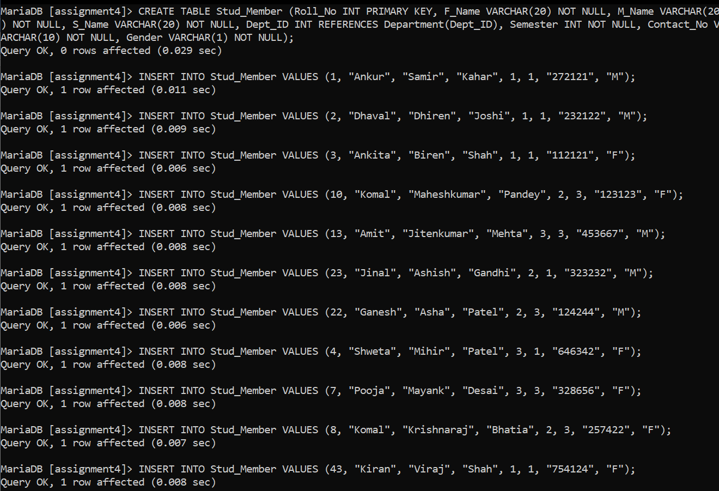

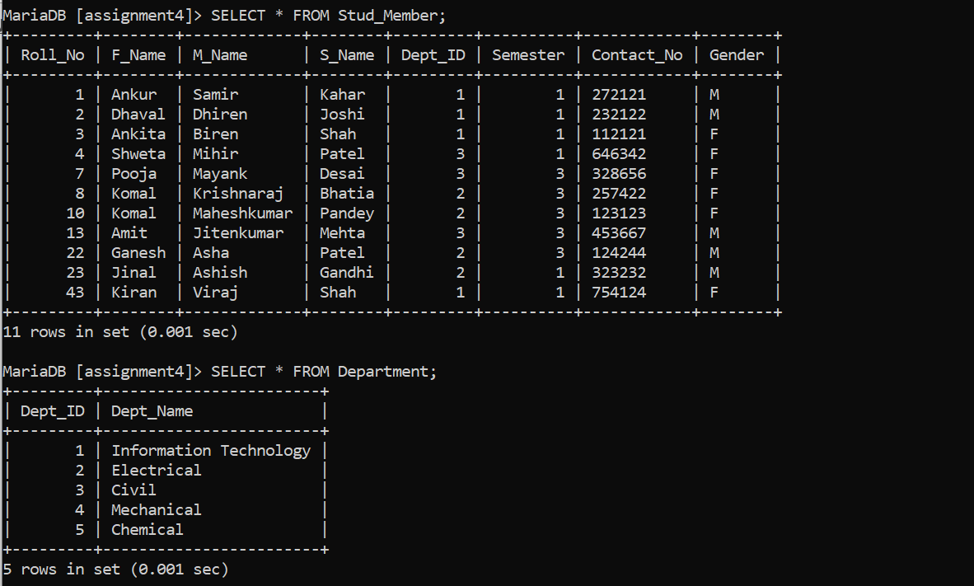

**1.Display the names and contact number of all student member**

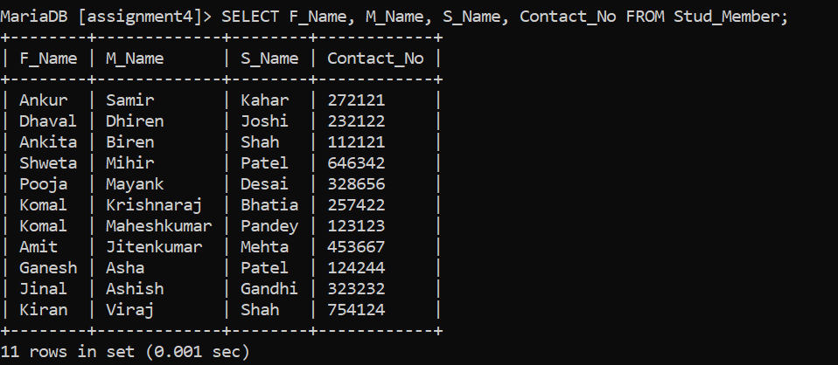

**2.Give the names and roll numbers of all students of information technology who are the members**

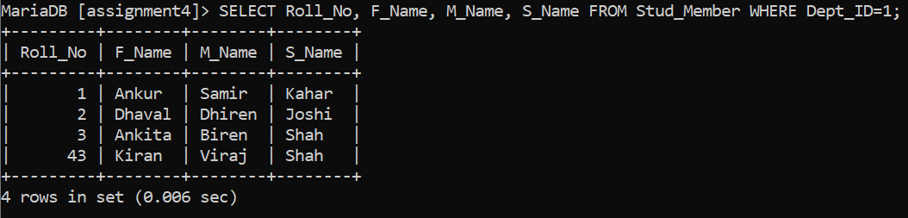

**3.Display the names of department whose students are members**

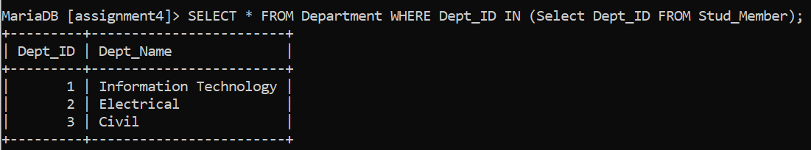

**4.Display the names of departments for which no student are the members**

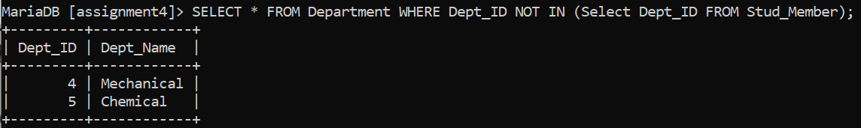

**5.Display the names of all departments**

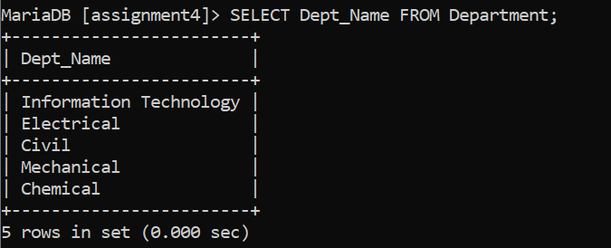

**6.Find the names of students of electrical department who are the members**

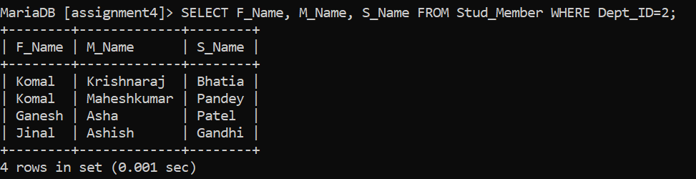

**7.Display the information of students’ members whose names begin with the letter A**

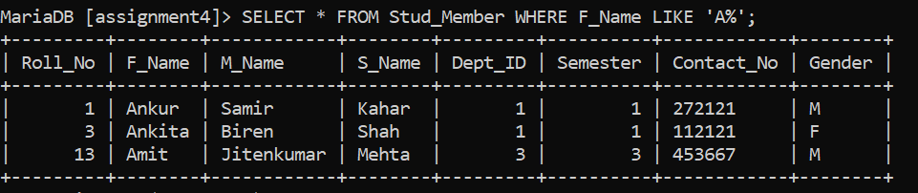

**8.Display all the details of male members only**

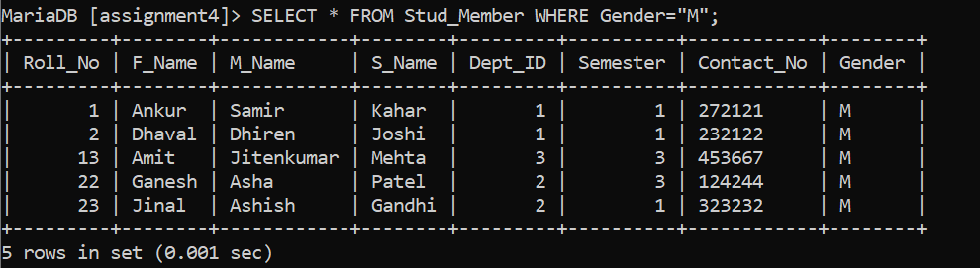

**9.Display the data of student members who are currently in semester 3**

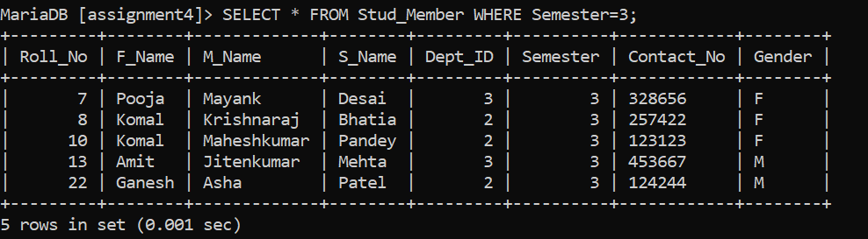

**10.Display the data of student female member in alphabetic order**

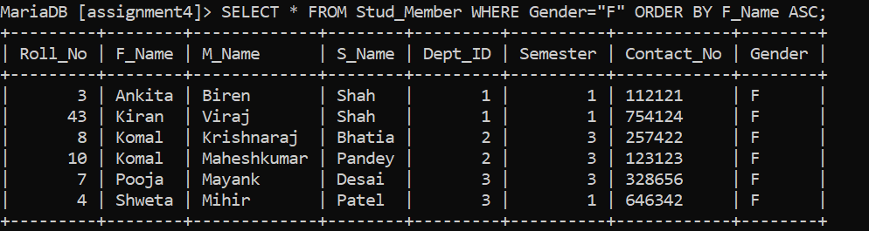

**Q2 Consider the following relations and operate the given queries Table:**

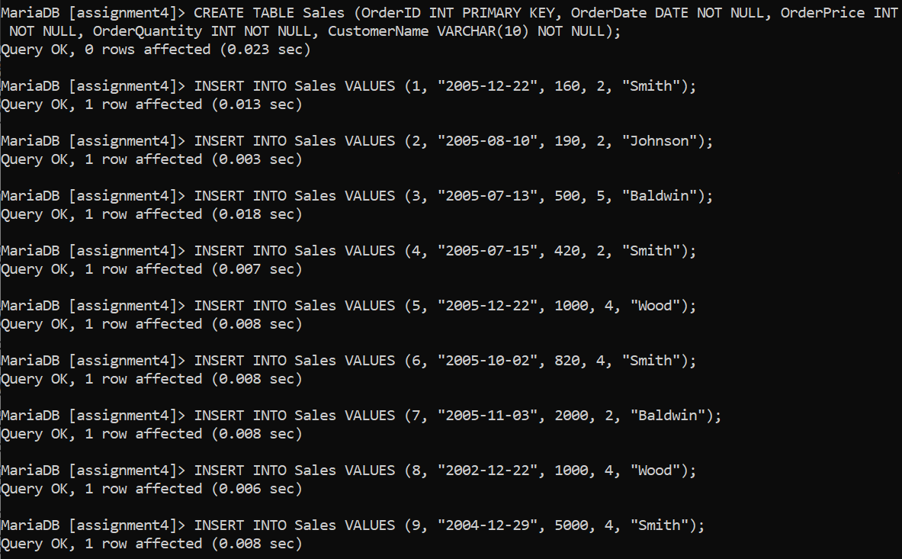

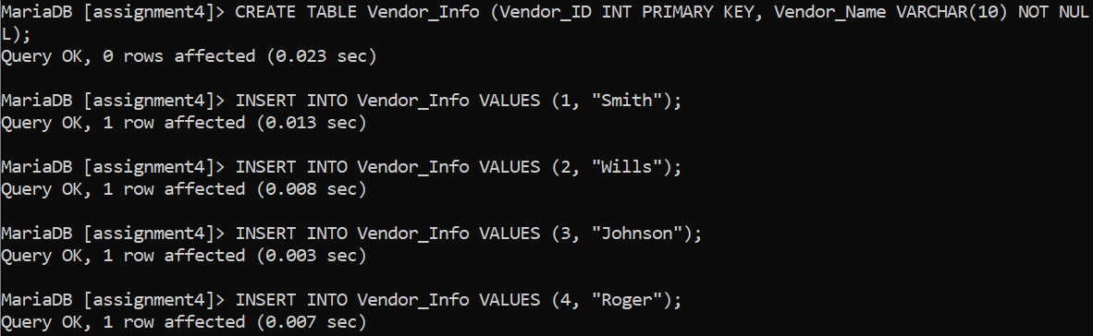

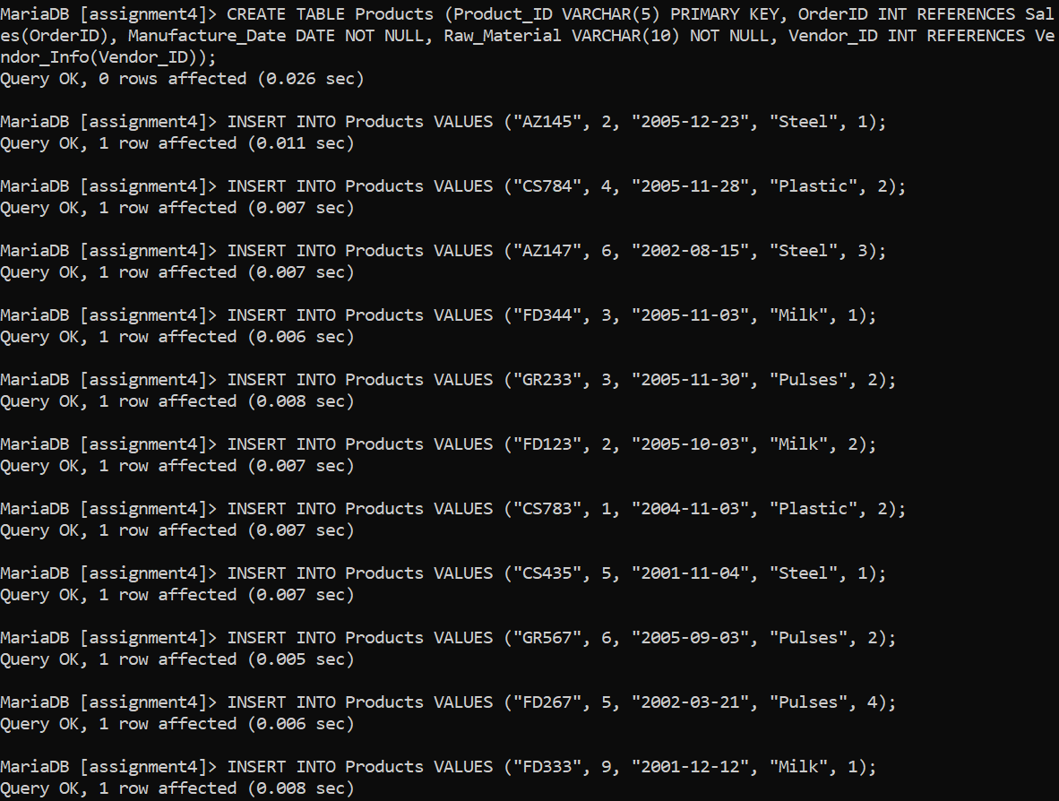

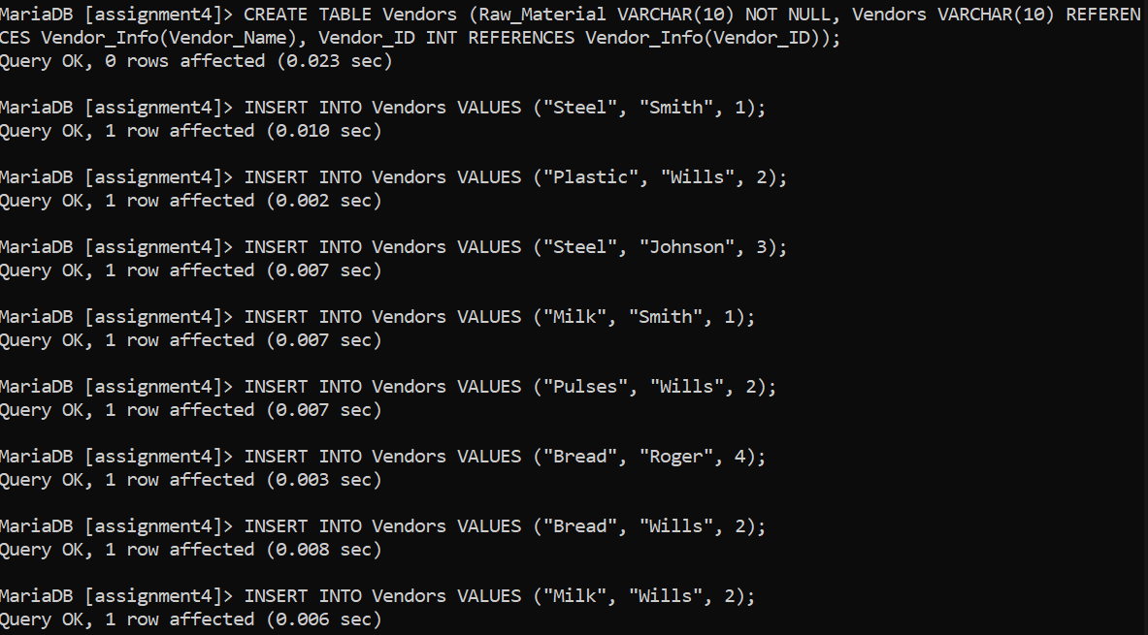

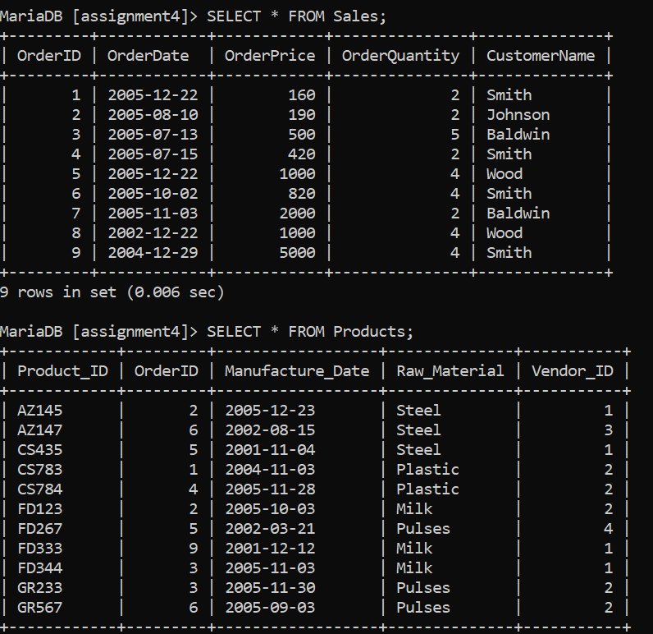

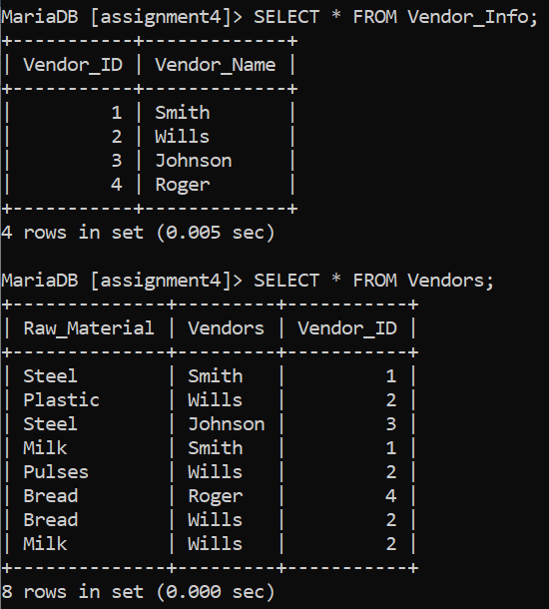

**1.Display product information which are ordered in the same year of its manufacturing year.**

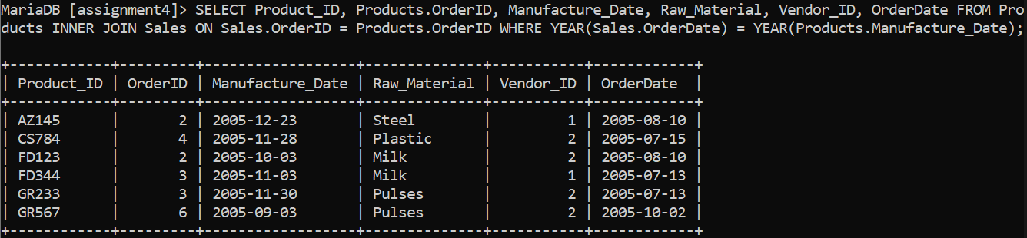

**2.Display product information which are ordered in the same year of its manufacturing year where vendor is “smith”.**

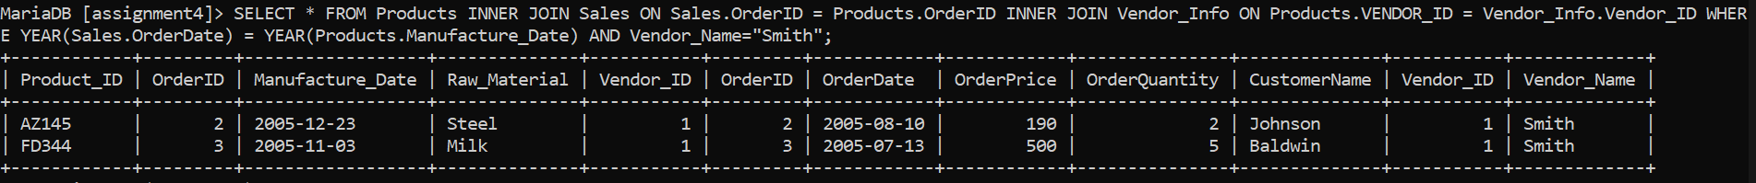

**OR**

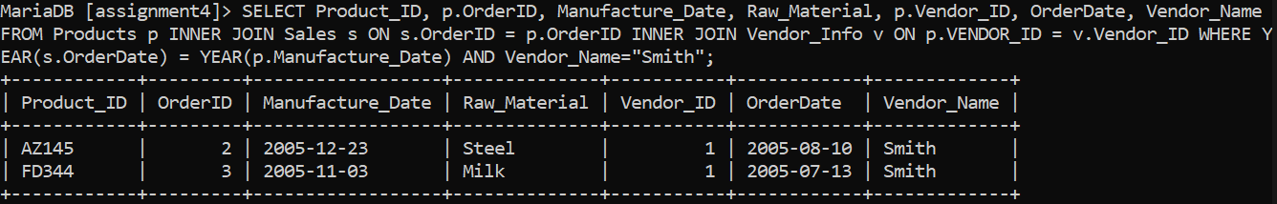

**3.Display total no. of orders placed in each year.**

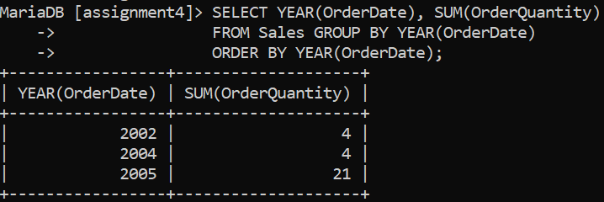

**4.Display total no. of orders placed in each year by vendor Wills.**

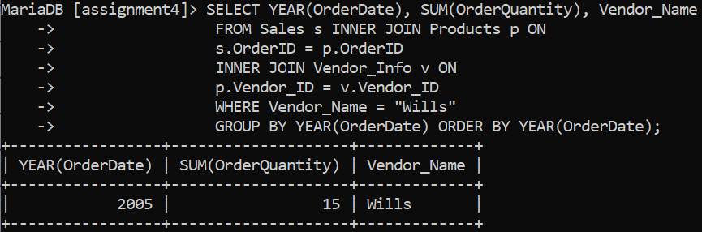

**5.Display the name of all those persons who are vendors and customers both.**

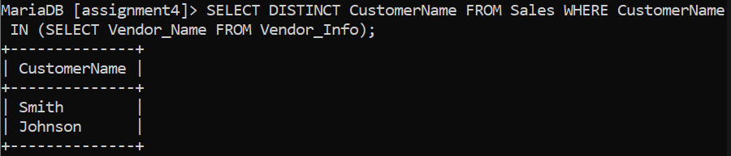

**6.Display total no. of food items ordered every year.**

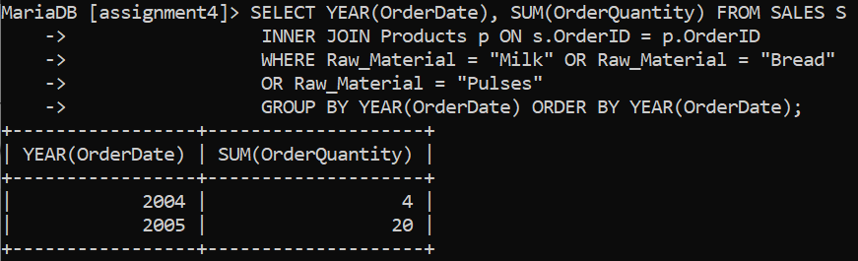

**7.Display total no. of food items ordered every year made from Bread.**

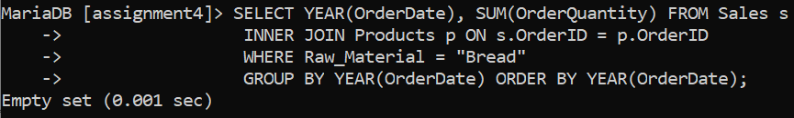

**8.Display list of product_id whose vendor and customer is different.**

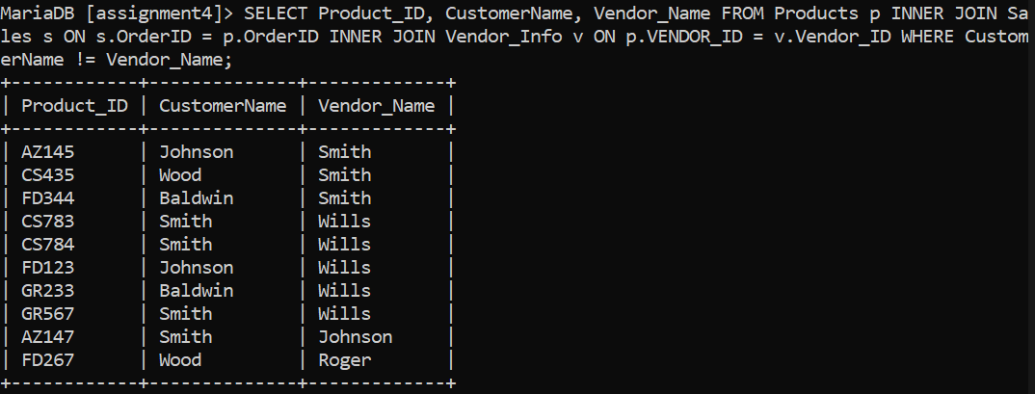

**9.Display all those customers who are ordering products of milk by smith.**

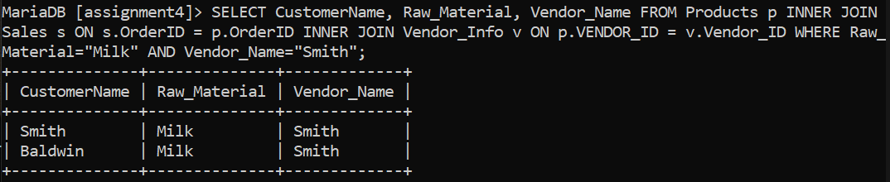

**10.Display total no. of orders by each vendor every year.**

